Job Aid
Disaggregating Office Discipline Referral (ODR) Data using SWIS to Examine Discipline Outcomes for Subgroups of Students

Why Disaggregate Discipline Data by Subgroups?
Use of a web-based data management system to record and summarize Office Discipline Referral (ODR) information, such as the School-wide Information System (SWIS), allows schools to make informed decisions about how to support student behavior. Analysis of behavior patterns at the school-wide level (e.g. the most frequent problem behaviors in the cafeteria) provides insight into how to structure behavior support practices for all students. Analysis of individual student behavior ensures that intensive, individualized behavior support is tailored to the needs of the student, increasing the likelihood of success. However, in order to ensure that each and every student is receiving the behavior support that he or she needs to be successful, schools must also analyze ODR data by subgroups of students.
America’s academic achievement gap for students with disabilities, students of color, and students learning English has made headlines for many years (National Education Association, 2015). A discipline gap exists for the same subgroups of students, with much research focusing on the gap for students of color (Losen, D. et al, 2015). As educators, we must take action towards righting these inequities. Any action should begin with an analysis of the current state of discipline disproportionality. Disaggregation of discipline data using SWIS is an important first step for any school to begin the process of addressing equity for all students.
The following Job Aid is meant for schools currently using SWIS. For more information regarding SWIS, please contact SERC at (860) 632-1485.

Using SWIS to Disaggregate Discipline Data by Subgroups
SWIS data can be disaggregated multiple different ways. The following provides SERC’s recommended method of disaggregation, with a specific focus on reviewing discipline data for students of color.
- Use SWIS’s Referrals by Ethnicity report as a starting point
  - Select View Reports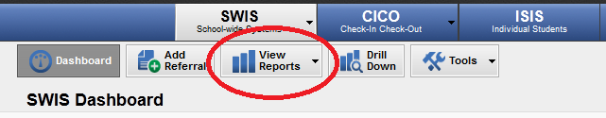

  - Select Ethnicity
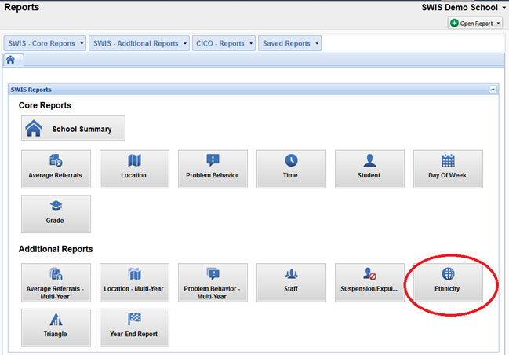

  - Review resulting reports:
- Referrals by Ethnicity
  - This report compares the proportion of all referrals vs. the proportion of the student population by ethnicity. For example, as depicted in the graph below, Black students account 18% of all referrals, but only 9% of the student population.

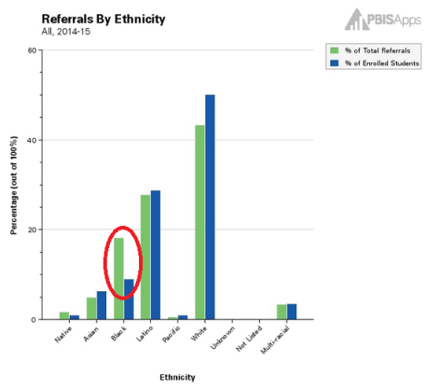
If the percentage of total referrals (green bar) is higher than the percentage of enrolled students (blue bar) for an ethnicity, this indicates that students of that ethnicity are being over represented in referrals.

- Students with Referrals by Ethnicity
  - This report compares the proportion of students receiving referrals vs. proportion of the student population by ethnicity. For example, as depicted in the graph below, Black students account for 15% of all students receiving referrals, yet only 9% of the student population.

As the previous graph showed, 18% of all referrals were given to Black students. Now, 15% of all students who received referrals are Black. This indicates that at least one Black student received multiple referrals. This might be considered the unduplicated count.

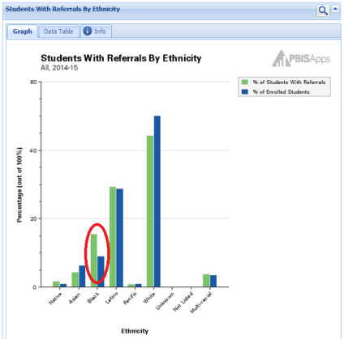
If the percentage of students with referrals (green bar) is higher than the percentage of enrolled students (blue bar) for an ethnicity, this indicates that students of that ethnicity are being over represented in students being referred.

- Students Within Each Ethnicity With Referrals

How to Dig Deeper into Discipline Data
- Use

References
National Education Association (2015). Students Affected by Achievement Gaps. Retrieved from www.nea.org/home/20380.htm.
Losen, D.; Hodson, C.; Keith II, M.; Morrison, K.; and Belway, S. (February, 2015). Are We Closing the School Discipline Gap? Retrieved from http://civilrightsproject.ucla.edu/resources/projects/center-for-civil-rights-remedies/school-to-prison-folder/federal-reports/are-we-closing-the-school-discipline-gap/AreWeClosingTheSchoolDisciplineGap_FINAL221.pdf.

